Treatment and Safety of Drinking Water
water treatment processes had a major impact on water-transmitted diseases, and these processes provide barriers—or lines of defense—between the consumer and waterborne disease. The most common treatment process train for surface water supplies—conventional treatment—consists of disinfection, coagulation, flocculation, sedimentation, filtration, and disinfection.
The purpose of drinking water treatment is to produce water that is chemically, biologically, and aesthetically pleasing. If the raw water is clean, less treatment steps are needed, and hence, the overall cost is less. In urban areas, a significant amount of the population is connected to a municipal water supply system, whereas in rural areas, water supplies usually come from private or shared wells. Production of drinking water is an energy-demanding process since the water source is not always clean. Drinking water treatment methods differ between regions, but in general, the treatment involves a few key steps. Common treatment methods include aeration, flocculation, sedimentation, filtration, and disinfection. In addition, the water supply needs to be checked at regular basis to ensure that satisfactory water quality is maintained.

Conventional surface water treatment plants have a standard sequence of processes. After screening out large objects like fish and sticks, coagulant chemicals are added to the water to cause the tiny suspended particles that make the water cloudy to be attracted to each other and form “flocs.” Flocculation—the formation of larger flocs from smaller flocs— using gentle, constant mixing of the water to encourage particles and small floc to “bump” into each other, stick, and form larger floc. Once the flocs are large and heavy enough to be settled, the water moves into quiet sedimentation or settling basins. When most of the solids have settled out, some form of filtration either with sand or with membranes typically occurs. Disinfection is the next step. After disinfection, various chemicals added to adjust pH, to prevent corrosion of the distribution system, or to prevent tooth decay. Ion exchange or activated carbon used during this process to get rid of inorganic or organic contaminants. Groundwater sources generally have higher initial quality and tend to require less treatment than surface water sources.
Coagulation and flocculation are essential pretreatments for many water purification systems.
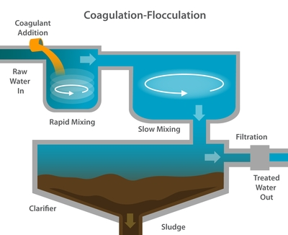
In conventional coagulation-flocculation-sedimentation, a coagulant is added to the source water to create an attraction among the suspended particles. The mixture is slowly stirred to induce particles to clump together into “flocs.” The water is then moved into a quiet sedimentation basin to settle out the solids.
Filtration systems treat water by passing it through beds of granular materials (e.g. sand) that remove and retain contaminants. Conventional, direct, slow sand, and diatomaceous earth filtration systems removes most protozoa, bacteria, and viruses (if coagulation is used)
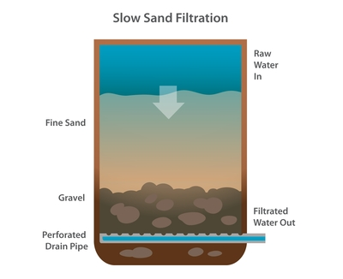
Conventional filtration is a multistage operation. First, a chemical coagulant such as iron or aluminum salts is added to the source water. The mixture is then stirred to induce tiny suspended particles to aggregate to form larger and more easily removable clots, or “flocs.” These coagulated masses, or “flocs,” are then allowed to settle out of the water, taking many contaminants with them. Once these processes are complete, water is passed through filters so that remaining particles attach themselves to filter material.
Direct filtration is similar to conventional filtration, except that after the coagulant is added and the mixture stirred, there is no separate settling phase. Rather, the suspended particles are destabilized by the coagulant and thus attach more readily to the filter material when the water is then filtered.
Slow sand filtration systems have no coagulation and, usually, no sedimentation step. Water is induced to pass slowly downward through a bed of sand some two to four feet (0.6 to 1.2 meters) deep. A biologically active layer forms along the upper surface of the sand bed, trapping small particles and degrading some organic contaminants.
Membrane water treatment systems were originally used only in desalination projects. But improvements in membrane technology have made an increasingly popular choice for removing microorganisms, particulates, and natural organic materials that foul water’s taste and taint its clarity.
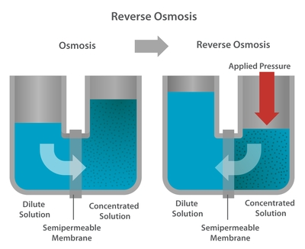
Water treatment membranes are thin sheets of material that are able to separate contaminants based on properties such as size or charge. Water passes through a membrane; but depending on their size, larger particles, microorganisms, and other contaminants are separated out.

Some of these systems are pressure driven, depending on water pressure to separate the particles based on size. Microfiltration employs the largest pore size, and remove sand, silt, clay, algae, bacteria, Giardia, and Cryptosporidium. Ultrafiltration also remove viruses. Nanofiltration systems provide nearly complete protection against viruses, remove most organic contaminants, and reduce hardness in water. Reverse osmosis systems are dense membranes that remove almost all inorganic contaminants and all but the smallest organic molecules.
Electrodialysis combines membrane technology with the application of electrical current, to separate contaminants based on charge. Unlike other membrane processes, the source water never passes through the membranes during electrodialysis. it is mostly used for medical and laboratory applications that need ultrapure water.
Disinfection systems are used to combat waterborne diseases caused by bacteria or viruses. These processes neutralize pathogens by treating source water with chemical additives, or through exposure to ultraviolet light. These treatment systems are often inexpensive and can easily be scaled down for low-volume treatment facilities.
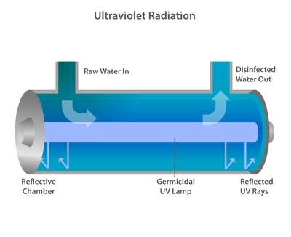
Free chlorine, chloramines, and chlorine dioxide are common disinfectants. Chlorination is the most popular (and oldest) class of chemical additives. Chlorine is also an oxidizer, so it helps to remove iron, hydrogen sulfide, and other minerals.
Ozone, a colorless gas, treats organic and inorganic contaminants it is more effective against bacteria and other germs. Ozone systems are uncommon in much of the world because they are infrastructure intensive, and they are expensive to implement.
Ultraviolet light, an invisible part of the electromagnetic spectrum that kills bacteria and viruses in water exposed to its rays, is typically produced using mercury lamps. The UV process is affordable and popular with small-scale facilities but is not as effective as other disinfectants on surface water supplies containing lots of suspended particles.
Adsorption systems treat water by adding a substance, such as activated carbon or alumina, to the water supply. Adsorbents attract contaminants by chemical and physical processes that cause them to ‘stick’ to their surfaces for later disposal.
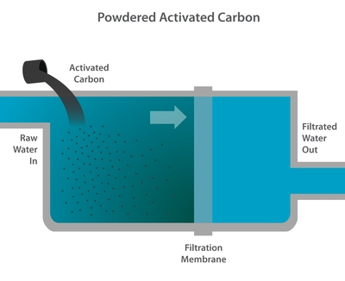
The most commonly-used adsorbent is activated carbon—a substance similar to common charcoal but extremely porous. Powdered activated carbon is often used when temporary quality problems arise; it can simply be added to the water and discarded with waste sludge. Granular activated carbon is often arranged in a bed through which source water is slowly passed or percolated.
Activated alumina treatment is used to attract and remove contaminants, like arsenic and fluoride, which have negatively charged ions. However this is expensive and require complicated system maintenance. Also, the water may require pH adjustment prior to the adsorption column, and a significant aluminum residual is a common problem. Both acids and bases are required for regeneration.
Ion exchange uses a resin that removes charged inorganic contaminants like arsenic, chromium, nitrate, radium, uranium, and excess fluoride by exchanging them for harmless charged ions on its surface. It works best with particle-free water and can be scaled to fit any size treatment facility. Ion exchange is most often used to remove hardness (cation resin) or nitrate (anion resin). In both instances, it can be regenerated with salt water. The use of ion exchange to remove radionuclides is complicated by the fact that these materials accumulate in the resin and occur at high levels in the regenerant, greatly complicating operations.
Activated carbon is generally preferred for removing organic contaminants, whereas ion exchange is best for removing inorganic soluble molecules.
Air stripping systems, also known as aeration systems, mix air with a water supply. The goal is to generate the largest possible air-water contact area so that volatile organic chemicals and dissolved gasses such as radon and hydrogen sulfide will move from the water to the air.
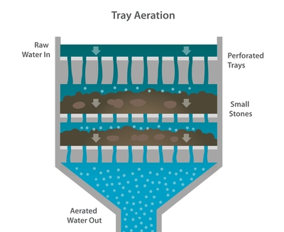
Packed tower systems use a distributor to introduce water evenly across the top of a tower packed with plastic, ceramic, or metal objects engineered to maximize air-water contact. Air is pushed or drawn upward through the tower in a direction counter current to the water.
Tray aeration systems arrange packing materials in vertical trays and drip water through them.
Diffused aeration systems force compressed air through diffusers at the bottom of a basin. Mechanical aeration systems work by vigorously agitating the water surface with a mixer.
air stripping systems are prone to clogging because of particulates, rust-producing bacteria, and precipitation of calcium carbonate. Treatment costs increase significantly if water must be pre-treated or if system air must be purified before it is released into the atmosphere.
None of the air stripping systems is designed to be effective against microorganisms. All require a reliable power supply, except for tray aerators, which are designed to use natural air convection and gravity, and therefore can often be operated without power.
Solar water treatments take advantage of natural cleansing processes found in nature and enhance them for more efficient results. Compact and even portable solar units are popular at the household level. This is a good treatment option for developing nations with an abundance of sunny days because they are inexpensive and require almost no investment or infrastructure.
Solar distillation involves putting unpurified water into a container, evaporating it using the sun’s rays, and condensing it into a separate container. Most contaminants such as salts, heavy metals, and microbes stay behind in the unpurified water container, which can be periodically discarded.
Solar disinfection uses the Sun’s ultraviolet rays to kill pathogens. A plastic or glass bottle of untreated water is placed on a roof or a corrugated iron surface. Given enough time and sunlight, ultraviolet light in combination with high temperature kill most viruses, bacteria, and protozoa.
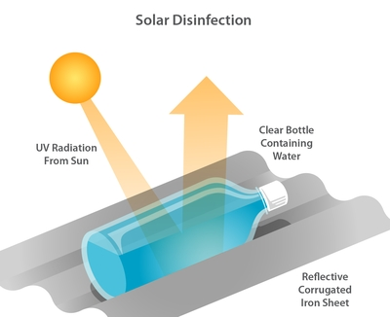

Safety of drinking water
Safe drinking water is defined as the water that does not represent any significant risk to health over a lifetime of consumption. The safe drinking water must be delivered that is pure, wholesome, healthful and potable.
There are basic standards, norms, criterion and indicators for safe drinking water. There are also policies, strategy and program under safe drinking water.
The WHO Guidelines for drinking-water quality recommend water safety plans (WSPs) as the most effective means of consistently ensuring the safety and acceptability of a drinking-water supply.

Water regulations and act
Water regulations are important for the provision of drinking water that is sufficient in quantity, safe, accessible, acceptable, affordable and reliable. Drinking water regulations include controlling of the water supply systems which are water source, water treatment, distribution, use, wastewater and gray water.

